Session 14
1.
Create a table called Orders with columns: order_id, user_id, order_date, and total_amount. Insert at least 7 sample rows representing different users and dates, similar to how food orders appear in Zomato or Swiggy.
Ans :
USE demo;

DROP TABLE IF EXISTS Orders;

CREATE TABLE Orders (
order_id INT PRIMARY KEY,
user_id INT,
order_date DATE,
total_amount DECIMAL(10,2)
);

INSERT INTO Orders VALUES
(101,1,'2026-07-01',250.00),
(102,1,'2026-07-05',450.00),
(103,1,'2026-07-10',300.00),
(104,2,'2026-07-02',500.00),
(105,2,'2026-07-08',650.00),
(106,3,'2026-07-03',200.00),
(107,3,'2026-07-12',350.00);

SELECT * FROM Orders;
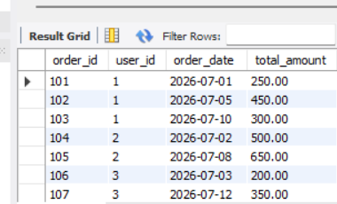

2.
Write a SQL query using the LAG() function to show each user's order_id, order_date, and the total_amount of their previous order (if any), ordered by user and date.<br><br><em><strong>Hint:</strong> Use PARTITION BY user_id and ORDER BY order_date in your window function.</em>
Ans :
SELECT
order_id,
user_id,
order_date,
total_amount,
LAG(total_amount) OVER (
PARTITION BY user_id
ORDER BY order_date
) AS previous_order_amount
FROM Orders;

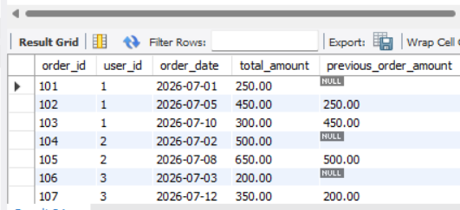
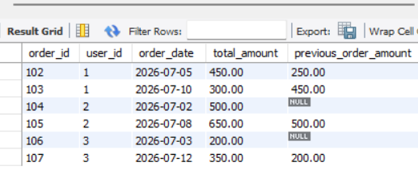
3.
Using the same Orders table, write a SQL query with the LEAD() function to display each order_id, order_date, and the next order's total_amount for the same user.
Ans :
SELECT
order_id,
user_id,
order_date,
total_amount,
LEAD(total_amount) OVER (
PARTITION BY user_id
ORDER BY order_date
) AS next_order_amount
FROM Orders;
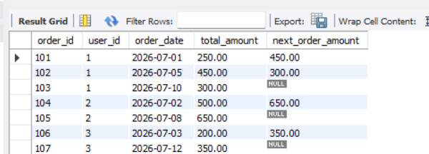
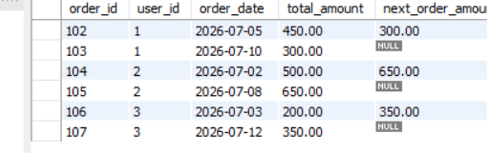
4.
Write a SQL query to calculate the running total of total_amount for each user, showing order_id, order_date, total_amount, and a column running_total that accumulates the sum as you move through each user's orders.<br><br><em><strong>Hint:</strong> Use SUM(total_amount) OVER (PARTITION BY user_id ORDER BY order_date ROWS BETWEEN UNBOUNDED PRECEDING AND CURRENT ROW).</em>
Ans :
SELECT
order_id,
user_id,
order_date,
total_amount,
SUM(total_amount) OVER (
PARTITION BY user_id
ORDER BY order_date
ROWS BETWEEN UNBOUNDED PRECEDING
AND CURRENT ROW
) AS running_total
FROM Orders;
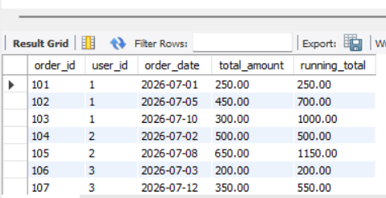
5.
Write a SQL query to calculate a 3-order moving average of total_amount for each user, showing order_id, order_date, total_amount, and moving_avg columns.<br><br><em><strong>Constraint:</strong> Use SUM() OVER() with ROWS BETWEEN 2 PRECEDING AND CURRENT ROW to compute the moving average.</em>
Ans :
SELECT
order_id,
user_id,
order_date,
total_amount,
AVG(total_amount) OVER (
PARTITION BY user_id
ORDER BY order_date
ROWS BETWEEN 2 PRECEDING
AND CURRENT ROW
) AS moving_avg
FROM Orders;
